Transformations using Geogebra
You will need to read the directions highlighted by Geogebra. Also, look at your data list to see if your measurements are being recorded as part of your proofs.
Construction 1 (Reflection of a figure)
- Using the polygon tool, draw a triangle
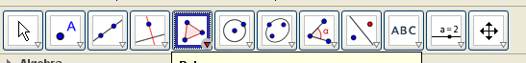
- Right click on the triangle and name it S. Make sure to turn on the labeling feature.
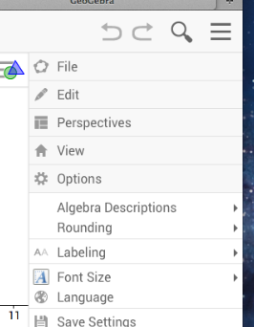
Use the drop down menu and choose options and labeling.
And choose automatic.
- Using the new point tool create two new points D and E. Choose the line through two points tool and choose D and E. Right click on the line and name it Q.
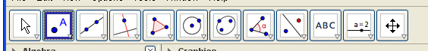
- Using the reflect object about line tool choose triangle S and line Q. Name the reflection of triangle S, S’.
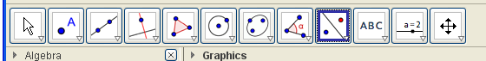
- Prove line Q is the perpendicular bisector of all the corresponding vertices.
Hint: you need to prove Line Q is perpendicular to one of the segments, and you need to show that distance from corresponding vertices to line Q is equal. Here is a tool to help:
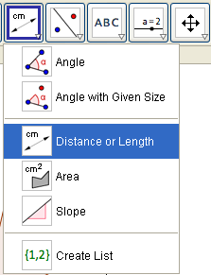
You can also use this tool to measure the angle. (Angle)
- Send screen shot to azimmer@wusd.org
Construction 2 (Rotation of a figure)
- Using the polygon tool, draw a triangle. Right click on the triangle to rename it P.
- Selecting the new point tool, create point D.
- Select the rotate and object around point by angle tool.
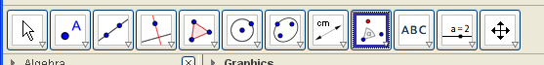
- Choose triangle P, point D, and insert an angle measure of 90 degrees counter clockwise (use degree symbol on menu)
- Label the rotation triangle P’.
- What rules exist between triangle P and P’? Show using the measuring tool that all corresponding segments to the center of rotation are congruent. Use this menu and use the angle tool to show that all the angles between corresponding points and the center of rotation point are congruent.
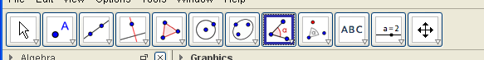

7. Send a screen shot to azimmer@wusd.org

Construction 3 (Translation)
- Draw any quadrilateral. Rename it T.
- Using the new point tool create points E and F below your figure. Choose the vector between two points tool.
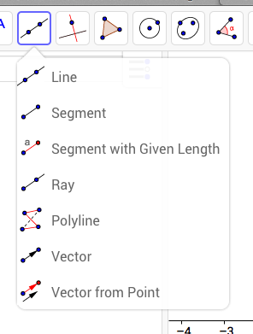
- Click point E and F to create a vector. Label the vector G by right clicking.
- Select the Translate object by a vector tool. Choose triangle T and Vector G. Label the translated quadrilateral T’.
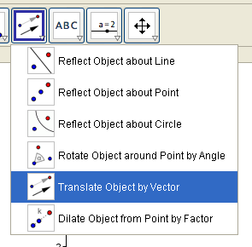
➔5. Write the vector rule as (x, y) ➔ (x ± . y ± ) It will in list as ( ). (You will need to figure out how to write on your screen by typing or free hand. You can do it!)
- Send a screen shot to azimmer@wusd.org.

